Meadows First School Knowledge Organiser SUBJECT PSHE | YEAR GROUP R TERM Summer 1  FOCUS/ THEME: Active Me
Techniques /Skills: | Key Vocabulary
Wellbeing Focus: Active Me  - Understand that exercise keeps me fit and healthy  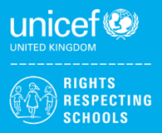  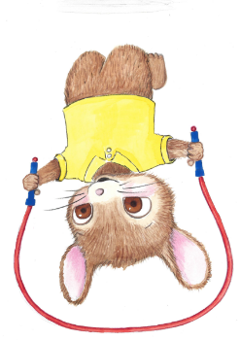  - Identify different ways to keep myself healthy | Word/ term definition  exercise physical activity that is done to help keep yourself fit and healthy  healthy having good health, not being sick or injured  fit physically healthy and strong
Key People / information | Resources: Books, internet sites and places to visit
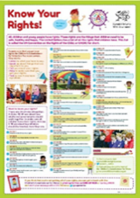  UNICEF Declaration of the Rights of the Child  Article 24: Every child has the right to the best possible health. Governments must provide good quality health care, clean water, nutritious food, and a clean environment and education on health and well-being so that children can stay healthy. | 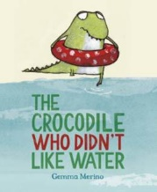  Web sites and books-possible alternatives  The Crocodile That Didn’t Like Water – Gemma Merino  See also  www.booksfortopics.com  www.booktrust.org.uk

