Meadows First School Knowledge Organiser ART Year R Spring 1 | Focus: PRINTING (line & pattern/ printing)
Drawing/ printing techniques | Key Vocabulary
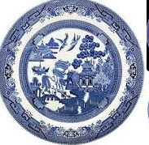  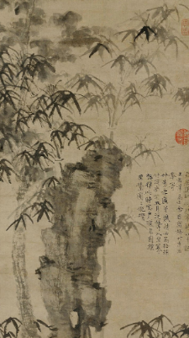  Explore patterns/ images marks telling the Willow pattern story on China – use line drawing techniques  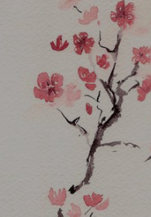  Explore traditional calligraphy techniques for blossom painting and the messages behind this art – have a go with pen and ink to look at Chinese calligraphy  Printing -explore monoprinitng to transfer the image of a willow pattern/ blossom – ink up a surface in blue and gently press paper on top and then scribe in detail – lift off paper to reveal the image underneath | Key Vocabulary Definition  printing Using objects and paint to make patterns and marks on paper  Mono printing Making a simple copy of a mark / pattern using paint and paper  calligraphy Decorative handwriting  rice paper Thin paper used for Chinese painting.  scroll A roll of paper or silk for writing or painting on.  ink stick A solid stick of ink.  ink stone A stone for grinding ink on.  porcelain A white translucent ceramic.  cobalt blue A deep blue pigment used on most Chinese ware
Key Artists | Books, internet sites and places to visit
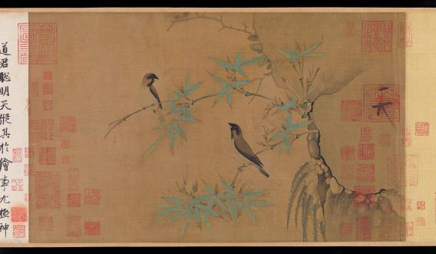  Finches and Bamboo Northern Song Dynasty – Early 12th century Handscroll - ink and colour on silk  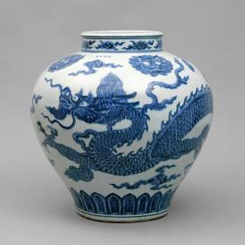  Ming dynasty – explore Chinese porcelain and the story of the Willow pattern | The story of the willow pattern in animation:  https://www.youtube.com/watch?v=sATUNcrVnCg  https://www.youtube.com/watch?v=Lj5uTZG6G90  simple mono printing techniques for drawing the willow pattern  