Meadows First School Knowledge Organiser ART | 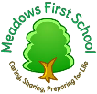  Year R Autumn 2 Focus: colour / line
Colour | Key Vocabulary
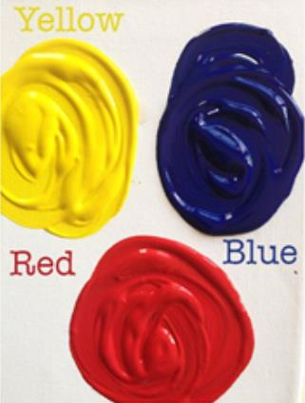  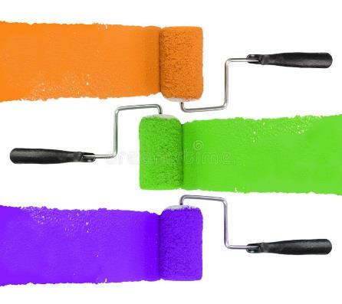  Primary colours =red blue yellow  Secondary colours =  Red+ yellow = orange  Blue + red = purple  Blue + yellow = green  Explore lines and mark making over the top of layers of paper/ tissue paper.  Draw on top of acetate/ and put tissue paper underneath  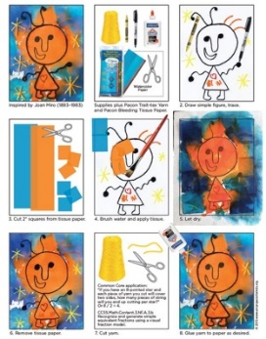  Take a line for a walk Miro style:  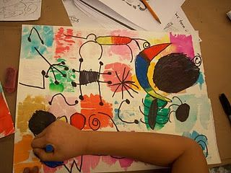 | Word/ term definition  Line – joins 2 dots together  Block colours a bold and solid colour  Primary colours red yellow blue (cannot be mixed to make)  Secondary colours are made using primary colours – orange purple green  Juxtaposition using strong bold contrasting colours next to each other
Key Artists | Books, internet sites and activites
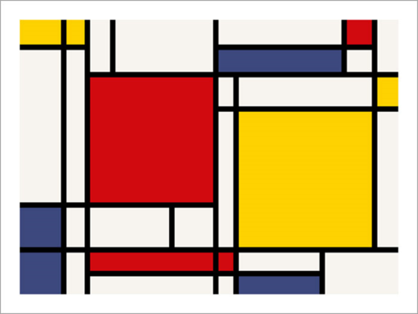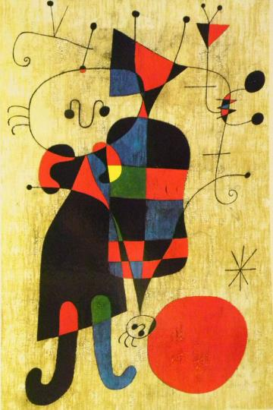  Piet Mondrian Miro | https://www.tate.org.uk/kids/explore/who-is/who-piet-mondrian  https://artprojectsforkids.org/category/view-by-artist/artist-joan-miro/  https://www.pinterest.co.uk/pin/561050066056936757/

