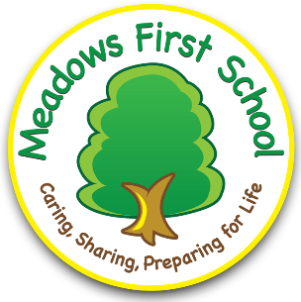
Eco-Schools Topic  Action Plan – 24/25  Waste / Air Quality | Action  Hold a whole School assembly Technical Officer - Air Quality Behaviour Change) to raise awareness of Air Quality and how to improve it in our locality  Further Eco meeting with Worcestershire Regulatory Services (Technical Officer - Air Quality Behaviour Change)  to discuss program outline and actions and share activities moving forward  Make air quality posters to be used for the Env Health services to be used as educational resources  Fundraising activity led by Eco team to raise money to buy air purifying plants for every classroom across the school  Display idling signs at the front of the school for parents and carers to see when dropping children particularly at breakfast club.  Whole School event - Take part in Clean air day June 2025 All children to take their learning outside for the whole day and turn of all electricity where possible | Duration – ongoing throughout the year  Who is responsible?  Eco Team  Mrs Ashton – Eco lead  Charlotte Hornblow and Heydi Horton –  Wyre Forest Council | Monitoring Method  Regular meetings with Heydi and Charlotte - Technical Officer - Air Quality Behaviour Change  Two weekly meetings with Eco committee to create resources and hold discussions regarding timelines etc
Aim  To develop further on from our idling campaign and focus on promoting clean air both in our classrooms and wider locality  Educate children about the negative affects of waste into the atmosphere and on our air quality |  | Informing & Involving Plans  Head made contact with Air Quality Leads at WCC  After the initial whole school assembly – Air quality and behavior change team met with Eco council to discuss clean air project and how we could be involved. The children had already talked about the need for air purifying plants in each classroom  The children wanted to raise money for the plants and so made Bees wax honey wraps to sell to parents after the Year 4 climate change protest  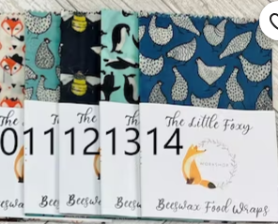  https://www.youtube.com/watch?v=AruJeIbb8fg  Bees wax wraps sold and raised £24 | Final Evaluation  Successful partnership with Heydi and Charlotte - Technical Officer - Air Quality Behaviour Change Worcestershire creating resources and educating children about air quality  Posters and resources shared with Wyre Forest to be used in future projects and informing other schools  Beeswax wraps made from donated materials from the local community and children made wraps and designed labels ready to sell  Eco Children linked with the Year 4 Climate Change protest selling the sandwich wraps or £2 each raising £34  Audit of plants in classrooms done and new air purifying plants bought for each classroom in need  New idling signs bought and put up in the car park in the front of school to remind parents about idling and the negative impacts on air quality -leading from previous Idling campai
Eco-Schools Topic  Marine | Action  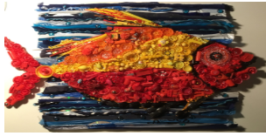  Create a single use plastic display to raise awareness of microplastics on the ocean  Trawler net or Fishing net?  Discuss using environmentally-friendly cleaning products with BAM.  Staff meeting with staff about laminating  Create an animation that makes the community aware of single use plastics on ocean health | Duration  Focus on this are during the Spring and summer term until the end of the year  Policies created to continue into the future | Monitoring Method  Two weekly meetings with Eco committee to create resources and hold discussions regarding timelines etc
Aim  Raise awareness of microplastics in the ocean and plastics that can or cannot be recycled |  | Informing & Involving Plans  We took part in The Great British Spring Clean and Great Big School Clean from 21 March - 6 April 2025. And we sorted through the litter collected and focused on microplastics  Used the single use plastics that have been collected to create art work to be displayed on the eco board  Year 4 children had been learning how to create animations in computing – children wanted to create an animation about marine microplastics this was then added to our school eco page for the community to see | Final Evaluation  After taking part in our own school clean up we were able to see what litter was being found in the playground  We created litter bar charts showing types of litter collected and displayed them. We also created a litter display board using the litter we had collected as a further visual point.  Along with Year 4 – we created animations about ocean microplastics to be added to our school eco page for the wider community to see.
Eco-Schools Topic  Litter | Action  Take part in The Great British Spring Clean and Great Big School Clean from 21 March - 6 April 2025.  Litter audit – to see what products are being thrown away  How many are single use plastics??  Anti-litter posters created and displayed around the school  Share litter picking equipment with wider community  Feeding on from air quality project and to reduce cling film being used and fundraise - Have a Bees wax Honey Wraps fundraiser!  Whole school newsletter – request cotton linens for an eco- project  Replace and reinstate compost bins so that children are not throwing away fruit that could be recycled – monitors for collecting and putting on the compost heap  Could walk to school be linked to collecting plastic?? On 19-23 May 2025 | Duration  Ongoing throughout the year  Who is responsible?  Eco Team  Mrs Ashton – Eco lead  SLT | Monitoring Method  Litter pickers chosen and rota created by Eco members to share responsibility and make it sustainable - Litter picking daily in both KS1 and KS2  Frequent opportunities throughout the year to assess litter on the playgrounds
Aim  To reduce the use of single use plastics within schools and in the wider community |  | Informing & Involving Plans  Linked to our first topic – ‘clean air’ the children wanted to raise money to buy plants – idea of creating an eco-friendly recyclable product instead of single use cling film that could be sold to parents to make money to buy air purifying plants  Successful project and children raised enough money for all classes to have plants in every classroom  Litter audit achieved – single use plastic was collected and used then as part of our marine focus  Posters created and displayed for the school as a reminder  Compost bins reinstated and used daily – transferred to compost bin in our allotment daily – eco team responsible | Final Evaluation  More awareness within school regarding single use plastics  Very successful Bess wax project - Wraps, created using recycled and unwanted material and repurposed from within our community. The money raised from the fundraiser meant we could buy one plant for each classroom!  Plants are now in every classroom and children are taking the plants home to water during the holidays  Many of the plants now are now producing spiderettes. Gardening club are now in the process of propagating them in order to create new plants Therefore expanding our spider plant collection within school without cost  Compost bins reinstated and collected every day into our allotment garden compost bin  Collection of litter pickers available constantly in the school office and can be taken on loan for a week at time - Walk to school week and litter picking linked and encouraged

