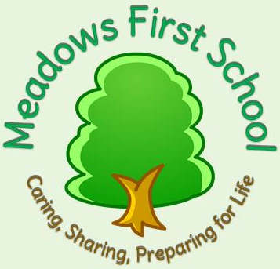

Meadows First School
If you would like to know more about signing with your child – please click on this website. Every Friday there are free resources to share, have a look!
http://www.signalong.org.uk/

