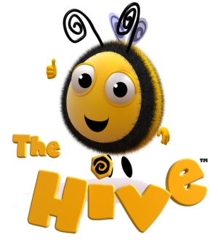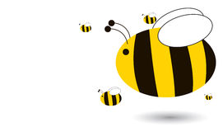

**Who is the Hive for?**

The Hive is a safe place for our **Bees**. Our bees are children who may need:

**B**ehavioural  
**E**motional or   
**E**ducational   
**S**upport   
  
Sometimes this support is for a very short time and sometimes this support is needed over a longer period of time.

This support is available for any child or family who needs it.

**What do the children do in The Hive?**

There are adults based in the Hive during key times during the day e.g. playtime and lunchtime.

* They listen and talk to the children.
* They allow the children some space and time to think and reflect.
* They allow children to play quiet games together with their friends.
* They help children to make good behaviour choices in class.
* They encourage children to think about their emotions.
* They look out for children around school who may need some support.

**When do children visit The Hive?**

1. The Hive is open to any child who needs some quiet time during playtimes and lunchtimes.   
2. Any child can choose to come and “play” in a supportive environment   
3. It is available for children who may need extra support with their behaviour or their emotions, in school or at home.  
4. It is available for small group work.

5. We run a breakfast club to allow some children to have a really happy and positive start to their day.

**Why do children visit The Hive?**

* Children sometimes need help to control and understand their emotions. The Hive is a good place to be if they are upset, angry or worried.
* Occasionally things happen at home that means a child might need extra support in school, for example, if a close family member is unwell.
* Children may need help with friendships.

**Where is The Hive?**

The Hive is a large, well equipped room upstairs.  
 It has a "chill out" corner, some individual work spaces, a large floor area, comfy chairs and some computers. It also has lots of resources to help children to learn about themselves.  
For more info email: hdodman@meadows.worcs.sch.uk