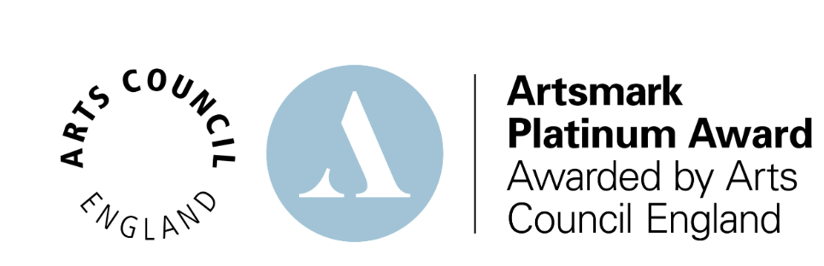

Message received from Arts Council England:
Congratulations! We are delighted to inform you that you have been awarded an Platinum Award!.
Every Artsmark Award is a significant achievement. Thank you for your commitment to embedding arts culture and creativity across your whole school. We know the work and effort that this takes and would like to use this opportunity to thank you as the Artsmark lead for completing an Artsmark journey. We hope you have seen the real impact that you have had.
We’re pleased to share feedback from our Assessors with you regarding your submissions:

“Meadows First School presents a thoughtful, rights-led approach to cultural education, grounded in a deeply inclusive ethos that positions the arts as a vehicle for voice, wellbeing, and citizenship. Your submission reflects a strong strategic alignment between your arts offer and your school’s core priorities, including the promotion of global awareness, mental health, and children’s rights under Article 31 of the UNCRC. The scale and ambition of some of your work with children and young people is particularly striking. For example, your film-based advocacy project addressing anti-idling and environmental concerns demonstrates how learners are not just participating in the arts but using them as tools for real-world influence and social action. Your diversity calendar, meanwhile, provides a framework for a culturally responsive and representative curriculum, and the way you integrate this across subjects speaks to strong curriculum design intent and coherence. It would be valuable to hear more about how the curriculum offer covers the discrete teaching of the arts. Are drama and dance taught within the curriculum as subjects? How are the visual arts taught? How much composing is there in Music? Does your cross-curricular use of the arts impact wider learning and how can you evidence this? Your well-scaffolded programme of arts engagement includes visiting artists, cathedral exhibitions, and community performance, but more importantly, you have used these experiences to deepen learning and anchor children’s experiences in their cultural context. To strengthen this work further, you might consider how to evidence progression across all arts disciplines more explicitly, including how pupils build skills and knowledge year on year, and how this supports the most able learners to deepen their practice. This will be valuable in your developing outward-facing work. Hosting CPD and sharing your approach to inclusive arts and rights-based education illustrates developing influence and leadership, and it will be valuable to track how this informs other schools’ action planning. You may also wish to more formally capture the impact of your outreach work on others - through feedback, follow-up engagement, or collaborative evaluation - so the influence you are having can be tracked and reflected on. Overall your journey represents an accomplished and confident submission that reflects a maturing cultural offer. Your approach to Equality, Diversity and Inclusion is a particular strength and the coherence of your development strategy speaks of strong Leadership. The coherence, leadership, and inclusivity of your approach overall suggest you are willing to not only reflect on what works but share such learning in accessible ways with your peers. To sustain and embed at Platinum level, you might reflect on elements of your arts practice that have room still to grow and develop. This will be enhanced by deeper Cultural Collaborations with arts organisations and arts educational network in which, perhaps, you can also take a strategic role, and through which you can strengthen your CPD offer for your own staff and for the wider educational community. We look forward greatly to hearing where your next journey takes you!”

