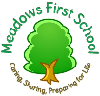  Meadows First School Knowledge Organiser SUBJECT PSHE | YEAR GROUP EYFS TERM Spring 1  FOCUS/ THEME: Unique Me-Sharing My Ideas
Techniques /Skills: | Key Vocabulary
Wellbeing Focus: Unique Me  - Is able to share their ideas and opinion.  - Is confident to talk and communicate freely about home and their wider community.  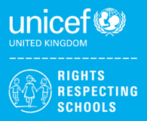  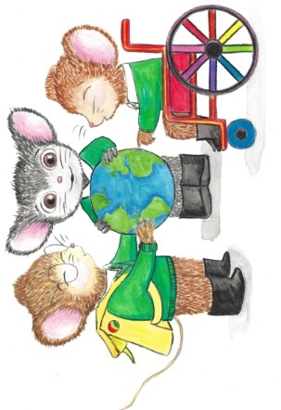  - Is able to listen well to other people when they are talking. | Word/ term definition  ideas a thought or plan  opinion what someone thinks about a particular thing  communicate to give information to someone by speaking writing or moving your hands  community a group of people who live in the same area  good listening paying careful attention to someone when they are speaking
Key People / information | Resources: Books, internet sites and places to visit
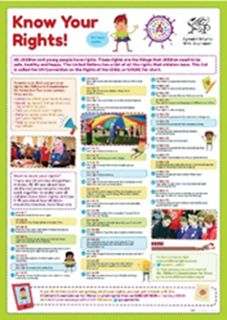  UNICEF Declaration of the Rights of the Child  Article 12 : Every child has the right to express their  views, feelings and wishes in all matters affecting them, and to have their views considered and taken seriously. | 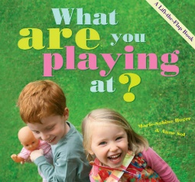  Web sites and books- possible alternatives  The Boy Who Loved Everyone - Jane Porter  What Are You Playing At? - Marie Sabine Roger  See also  www.amnesty.org.uk/books-younger-children  www.booksfortopics.com  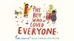  www.booktrust.org.uk

